**GUIDELINES**

**The 11th Southeast Asian Agricultural and Food Engineering**

**Student Chapter,**

**Annual Regional Convention 2025**

**Faculty of Engineering and Agro-industry, Maejo University (MJU) Chiangmai, Thailand**

**23-27 February 2025**

**Background of Event**

The Southeast Asian Agricultural and Food Engineering Student Chapter Annual Regional Convention (ARC) was founded by the Malaysian Society of Agricultural and Food Engineers (MSAE) in 2015. ARC is an annual activity for the engineering students' club in agriculture, involving participants from students across Southeast Asia, including Malaysia, Indonesia, Thailand, the Philippines, and other countries. This program has the potential to enhance networking within the industry and society at both national and international levels by bringing together students and academics from various countries.

The program aligns with government initiatives to empower agriculture and the food industries. It serves as a foundation for promoting agricultural and food engineering empowerment on a global scale.Agriculture stands as a pivotal income source in Southeast Asia, boasting fertile lands and abundant sunshine. With technological advancements, producers and consumers could gain benefits through sustainable development, both locally and globally.

Maejo University takes pride in hosting the 11th Southeast Asian Agricultural and Food Engineering Student Chapter Annual Regional Convention 2025. This event aims to showcase diverse agricultural and food industry innovations, fostering wellness and cultural exchange. Activities include professor talks, poster presentations, MyCobot challenges, technical tours, cultural performances, and more. The event will enrich academic and lifelong experiences for all participants.

**Purpose of the event**

The convention's primary aim is to offer undergraduate students from Southeast Asian countries like Malaysia, Indonesia, the Philippines, and Thailand a platform to present their projects and ideas. It also emphasizes cultural networking to highlight globalization and cross-cultural learning. Encouraging students in engineering and technology to participate will promote extracurricular activities that bridge classroom learning with real-world industrial challenges.

1. **Interactive poster presentation**

All participating teams will be invited to showcase their research findings and products and compete for a chance to win. The exhibition provides young engineers an excellent opportunity to explore, interact with, and learn about the latest innovations in engineering and agro-industry. Viewing their peers' exhibits allows them to discover new ideas, find solutions, and receive feedback to enhance their designs. Challenge outline is as follows:

1. All registered groups for ARC2025 must participate in this activity.
2. Participants are advised to dress formally and appropriately for the event with proper shoes.
3. The team must present a poster within a maximum of 3 minutes.
4. The presentation and judging of the poster will take place during the exhibition.
5. Participants will present the poster that has been printed in A1 size (59.4 x 84.1 cm).
6. The posters to be drawn must emphasize, illustrate, and interpret the theme of the convention: “Intelligent Agriculture and Novelty in Agro-Food Industry for Wellness”
7. Scoring Criteria:

|  |  |  |  |
| --- | --- | --- | --- |
| **No.** | **Criteria** | **Description** | **Mark (%)** |
| 1 | Content -originality. | The text and graphics used on the poster reflect an exceptional degree of student creativity in their creation or display. | 10 |
| 2 | Spelling / Grammar | English is grammatically correct. Scientific terms or acronyms are clearly defined or replaced with more familiar words. | 10 |
| 3 | Mechanics. | Capitalization and punctuation are correct throughout the poster. | 10 |
| 4 | Graphics – Accuracy. | The poster demonstrates the relevance of the research to a wide audience. | 10 |
| 5 | Graphics – Relevance. | All graphics are related to the topic and make it easier to understand. All borrowed graphics have a source citation. | 10 |
| 6 | Attractiveness. | The poster is exceptionally attractive in terms of design, layout, and neatness. The overall organization and use of color and space make the poster interesting. | 10 |
| 7 | Interesting media. | All media elements directly contribute to the main message or theme. | 10 |
| 8 | Complete information. | The text is clear, legible, and appropriately sized for easy reading. | 10 |
| 9 | Presentation. | Confident and engaging oral presentation. | 10 |
| 10 | Appropriate color and font selection. | Effective use of colors that are visually appealing and contribute to the overall theme. | 10 |
| **Total** | | | **100** |

1. Teams must abide by all rules and regulations set forth by the organizers, and failure to do so may result in disqualification.
2. Awards:

|  |  |
| --- | --- |
| 1st prize | Gold Medal + e-certificate |
| 2nd prize | Silver Medal + e-certificate |
| 3rd prize | Bronze Medal + e-certificate |
| Best Presenter | certificate |
| Best Poster | certificate |



1. **MyCobot Challenging**

Participants will compete to complete a series of pick-and-place tasks with accuracy and efficiency using the MyCobot 280 robotic arm.

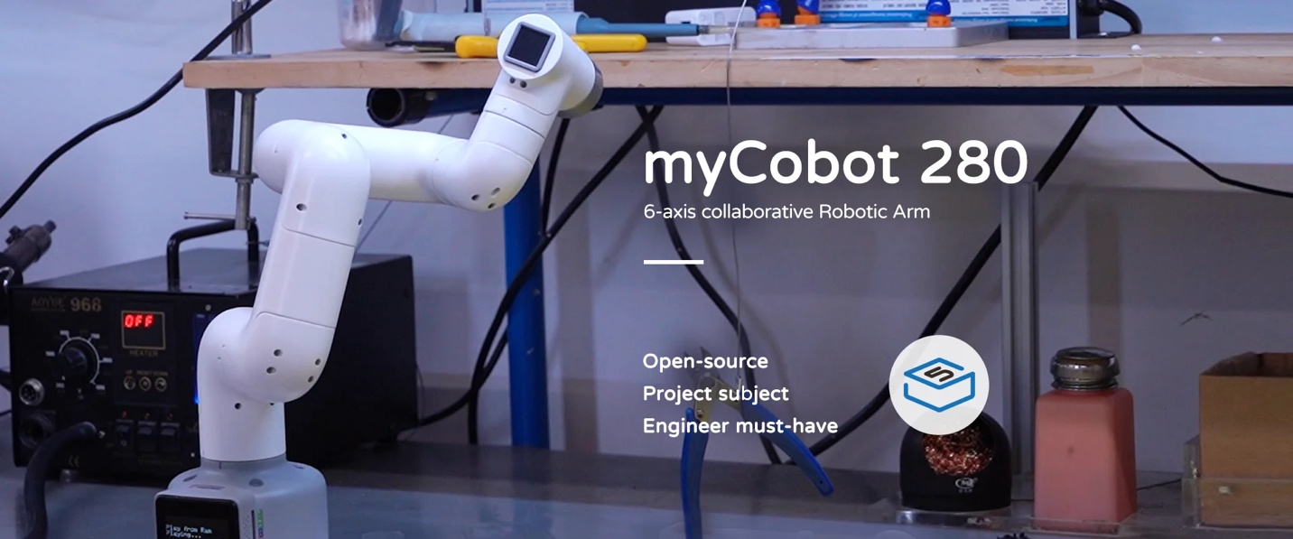

Challenge outline for "The Precision Pick-and-Place Challenge" is as follows:

1. All registered groups must participate in these activities.
2. Participants need to wear appropriate sports attire with proper shoes.
3. Introduction and learning

* Explain the key features of the MyCobot 280, such as its 6 degrees of freedom, 280mm reach, 250g payload capacity, and applications.
* Demonstrate how to securely place the MyCobot 280 on a workstation and connect the power supply. And show how to connect the MyCobot 280 to the computer via USB, Wi-Fi, or Bluetooth.
* Instruct participants to open MyCobot Studio and ensure their MyCobot 280 is recognized by the software.
* Explain how to use the manual control features in MyCobot Studio to move the robotic arm. Show how to use the interface to move the arm in different directions, rotate joints, and adjust the end effector.
* Introduction to Programming Modes: Explain the different programming modes available in MyCobot Studio, including block-based programming (Blockly) and script-based programming (Python).
* Demonstrate adding blocks to control the robotic arm, such as moving to a specific position, picking up an object, and placing it in a different location and show how to run the program and observe the robotic arm performing the tasks.

4) Competition

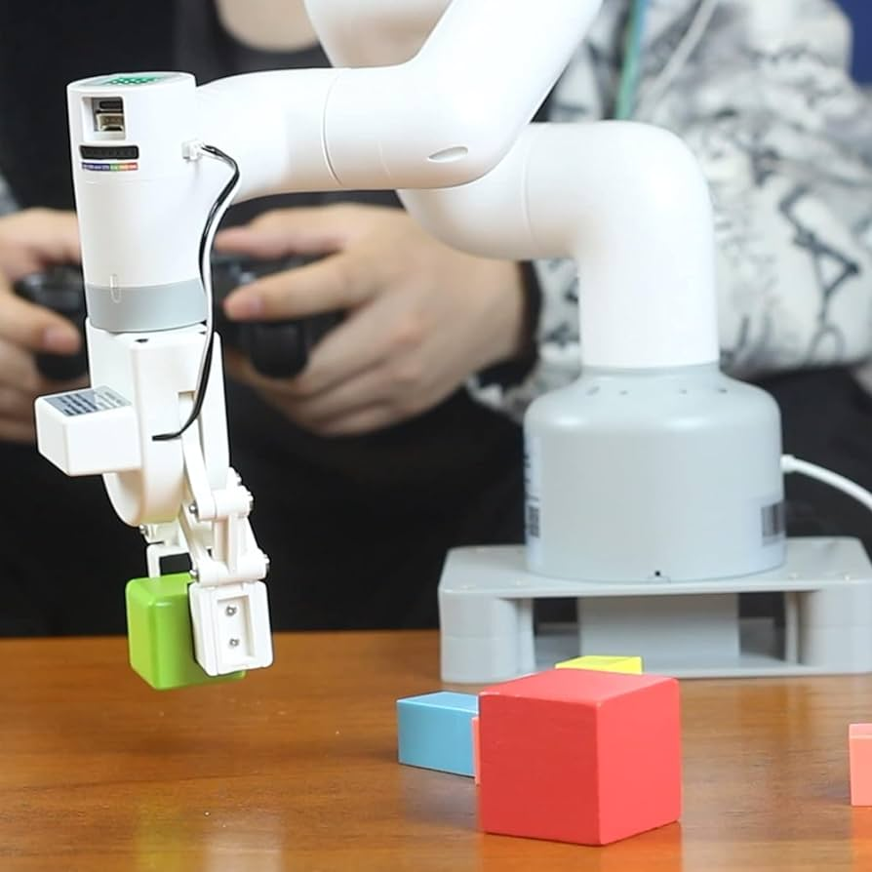

Ref: <https://www.amazon.co.uk/ELEPHANT-ROBOTICS-Collaborative-Programming-Applications/dp/B0B9S9D4ZT>

**Task 1: Basic Pick-and-Place**

* **Objective**: To pick up 5 objects from a designated area and place them accurately into corresponding slots.
* **Scoring**: Points awarded for accuracy, speed, and correct placement.

**Task 2: Obstacle Course**

* **Objective**: To navigate the MyCobot arm through an obstacle course without knocking over any barriers to pick and place an object at the end.
* **Scoring**: Points for completing the course, avoiding obstacles, and precision in placing the object.

**Materials provided:**

* MyCobot 280 robotic arms (one per participant or team).
* Objects for pick-and-place tasks (e.g., small blocks or balls).
* Obstacle course materials (e.g., small barriers, tape to mark paths).
* Colored blocks and bins for sorting task.
* Stationery for creative task (e.g., paper, markers).
* Computers with MyCobot Studio installed.
* Tables and workspace for each participant or team
  1. Awards:

|  |  |
| --- | --- |
| 1st prize | Gold Medal + e-certificate |
| 2nd prize | Silver Medal + e-certificate |
| 3rd prize | Bronze Medal + e-certificate |

1. **Vlog contest**

On February 24th, 2025, there will be technical tours to pilot plant, packing house, and many laboratories in Faculty of Engineering and Agro-industry and around MJU farm. These tours offer students valuable educational experiences.

Challenge outline is as follows:

1. All registered groups must participate in this activity.
2. Each group should make a vlog or short video lasting not more than 3 minutes.
3. The vlog material must be based on what the participants learned during the visit to faculty of Engineering and Agro-industry.
4. Each group is able to select one of the following topics:

-Agricultural engineering

-Food engineering

-Food science and technology

-Post harvest technology

-Rubber and polymer technology

1. Scoring Criteria:

|  |  |  |  |
| --- | --- | --- | --- |
| **No.** | **Criteria** | **Description** | **Mark (%)** |
| 1 | Content – originality. | The vlog materials must be based on what the participants learned during the visit. | 10 |
| 2 | Grammar and Vocabulary | English is grammatically correct. Scientific terms or acronyms are clearly defined or replaced with more familiar words. | 10 |
| 3 | Relevance | The vlog demonstrates the relevance of the research to a wide audience. | 10 |
| 4 | Innovation | Level of innovation and unique vlog presentation | 10 |
| 5 | Creativity | The capability or act of conceiving original or unusual ideas. | 10 |
| 6 | Presentation Effectiveness | The vlog has a clear beginning, middle, and end that features an introduction, methods, results and conclusion and is easy to follow. The main findings and their relevance are expressed well. | 10 |
| 7 | Visuals and  Graphics | Graphics, animation, and other visuals are effectively used to express the purpose and findings of the study and complement the audio. | 10 |
| 8 | Appropriate color and font selection | Effective use of colors that are visually appealing and contribute to the overall theme. | 10 |
| 9 | Delivery and  Narration | The narration is clear, relaxed, comprehensible, has a good pace and consistent in style throughout. The speech is expressive and offers a rhythm that encourages listening. | 10 |
| 10 | Time Management | Manages time effectively, meeting deadlines consistently. | 10 |
| **Total** | | | **100** |

1. Teams must abide by all rules and regulations set forth by the organizers and failure to do so may result in disqualification.
2. Awards:

|  |  |
| --- | --- |
| 1st prize | Gold Medal + e-certificate |
| 2nd prize | Silver Medal + e-certificate |
| 3rd prize | Bronze Medal + e-certificate |

1. By participating in the competition, participants agree to abide by these guidelines and the decisions of the judges are final.
2. **ARC maze race**

The Amazing Race-style program fosters teamwork, effective communication, and physical activity, contributing to overall well-being. Challenge outline is as follows:

1. All registered groups must participate in ARC maze race activities.
2. Participants should be physically fit and healthy to participate in moderate physical activities.
3. Participants need to wear appropriate sports attire with proper shoes.
4. Race route: The race route will usually be revealed prior to the start of the race, but the specific tasks and challenges may not be disclosed until teams arrive at each location.
5. Tasks and challenges: Teams will be required to complete various tasks and challenges at each location, which may involve physical, mental and cultural activities.
6. Winner’s selection will be based on time and completion of tasks
7. Participants are expected to exhibit good sportsmanship and respect for others throughout the race.
8. Teams must abide by all rules and regulations set forth by the organizers and failure to do so may result in disqualification.
9. Awards:

|  |  |
| --- | --- |
| 1st prize | Gold Medal + e-certificate |
| 2nd prize | Silver Medal + e-certificate |
| 3rd prize | Bronze Medal + e-certificate |

**F. Cultural Performances**

Cultural performances are intended to expose students to diverse cultures, promoting cultural awareness and understanding. Through these performances, students will learn the importance of appreciating global diversity, fostering tolerance, and respecting different cultural backgrounds. Additionally, these shows connect students with their own cultural identity and heritage while encouraging creativity, artistic expression, and interdisciplinary learning. Challenge outline is as follows:

1. The competition is open to groups consisting of more than three individuals.
2. Each institute is allowed to register only one performance group. However, different institutes can collaborate and form a performance group, subject to the suitability and approval by the organizer.
3. Each team will be given 5 minutes to perform, along with an additional 3 minutes for the stage preparation.
4. The performance should highlight cultural aspects while avoiding sensitive topics, races, religions, politics and any forms of provocation. The chosen theme should be respectful and inclusive.
5. Participants need to wear proper costumes that represent the culture they are showcasing. These costumes should be suitable and tasteful for the stage.
6. Participant groups are allowed to use either live instruments or recorded music for their performance. The music should enhance the performance and not distract from it.
7. Scoring Criteria:

|  |  |  |  |
| --- | --- | --- | --- |
| **No.** | **Criteria** | **Description** | **Mark (%)** |
| 1 | Creativity and innovation | How well does the performance represent the culture? Has its own creativity and innovation? | 10 |
| 2 | Stage presence and performance | How well does the group perform on the stage and engage with the audience? | 10 |
| 3 | Message and suitability | How well does the performance deliver a message and is it appropriate for the audience? | 10 |
| 4 | Costume / Music application | How well does the group present themselves, including their costumes and music that are chosen by group members? | 10 |
| 5 | Choreography / Script | Evaluate the organization and flow of the performance, including the choreography of dance or movement sequences. | 10 |
| 6 | Expression / Emotion | Evaluate how well the performers convey the emotions and meanings inherent in the cultural performance. | 10 |
| 7 | Group Members Synchronisation | Evaluate how well the synchronisation of the group members on the stage. | 10 |
| 8 | Cultural Authenticity | Demonstrate a profound understanding and respect for the cultural context, traditions, and aesthetics. | 10 |
| 9 | Cultural Education | Evaluate if there is a rich cultural education through the performance, enhancing the audience’s understanding and appreciation of the chosen culture. | 10 |
| 10 | Overall Performance | Is the performance polished and well-rehearsed, with seamless transitions, effective use of space, and a compelling overall presentation? | 10 |
| **Total** | | | **100** |

1. Awards

|  |  |
| --- | --- |
| 1st prize | Gold E-certificate |
| 2nd prize | Silver E-certificate |
| 3rd prize | Bronz E-certificate |

1. By participating in the competition, participants agree to abide by these guidelines and decisions of the judges are final.

**G. Awarding Night**

The award night is scheduled for February 26th, 2025 at Engineering building. This evening, the winners of the previous competitions will be revealed. It's a day to unwind before departure and enjoy the laid-back atmosphere of the farewell dinner, allowing everyone to relax after the competitive events. The event will let participants socialize, reflect on their experiences, and celebrate together before heading home. The farewell dinner and awards ceremony mark a celebratory finale to the event.

**REGISTER FEE**

**ARC Participant**

The early registration fees for ARC participants and accompanying officers are 2,000 THB (for local Thai participants) or USD 110 (for international participants) per person. The payment shall be made by October 31, 2024. The late registration fees for ARC participants and accompanying officers are 3,000 THB (for local Thai participants) or USD 130 (for international participants) per person. This fee includes:

●10 meals on 23-26 February 2025

●4 night accommodation (3 or 4 persons sharing room)

●Transportation for technical tours

●Transport from the airport (according to the scheduled time) and from the hotels

●Seminar Kit

**Payment method can be transferred to:**

(For payment, we will provide additional guidance after registration.)

**Contact Person**

Tithinun Rattanaplome

Email: **arc2025xmju@gmail.com**

Update 30/07/24